Assignment-8 EEC-3150 Engineering Programming II
- In the Blackboard Resources is a LinkedIn Learning course entitled Python Essential Training.

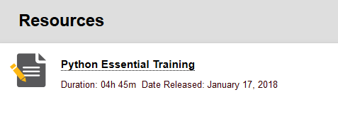
Review any lessons from the following chapters to increase your understanding:
Chapter 9 Classes

You may choose any of the videos, or all of the videos that will increase your knowledge of the Python programming language. You are to enumerate three learnings from the videos you have selected. Each of the three learnings should be described in one or two sentences.

- Create the abstract data type (ADT) "Class Person(object)" as shown in Figure 8.2 of the textbook. Please note that the name given during an instantiation is a space delimited string. The firstname is the string to the first space, the lastname is the string from the last space.

Make the following additions/changes to the Person ADT:
  - Add a new method called getFirstName
  - Add a new method called getBirthday

- Create a subclass of "Class Person(object)" called "Class TNUStudent(Person)". TNUStudent inherits all data and methods from Person, and adds a data item for student ID.

The TNUStudent ADT should provide the following:
  - Create a class-only value nextIDNum that starts at 1000 and is auto-incremented.
  - Provide a method called getIDNum

- Create a testing plan and build the main() that tests all methods from #2 and #3 above at least once. Create at least 3 instances of "TNUStudent" and print them sorted by student ID.

Summary: #2, #3, and 4 above are a single exercise. Provide only one Python program/script that includes the two ADT's and a single main(). In addition, your script/program should an informative header and comments throughout.
Submit: A file called Assignment-8-Results.docx to Blackboard.

